Jamaica’s Report on the 2008 Hurricane Season

Introduction
Since the turn of the century, Jamaica has faced direct threats of hurricane activity every year without exception. In 2001, hurricanes Chantal and Iris each placed the country on hurricane warning with the latter passing just 65 kilometres from the coastline. Michelle followed, initiating flash flood warnings and causing the dislocation of numerous residents due to excessive flooding and landslides.

2002 also had very close calls with tropical storms Isidore and Lili requiring tropical storm warnings as they passed within 50 kilometre of the island. Tropical storm warnings were also issued for Claudette and Odette in 2003, but the impacts on the country were significantly increased after hurricane warnings were issued for Charlie and Ivan in 2004. Destruction was rampant with Ivan, whose centre passed nearly 40 kilometres from the island’s southern coastline.

The approach of hurricanes Dennis and Emily elicited the issue of hurricane warnings once again for the country in July 2005. Both missed the “bull’s-eye”, passing 60 kilometres north and 150 kilometres south of the island respectively. Wilma was to follow later in the year prompting flash flood warnings and producing island-wide flooding. Ernesto was the lone threat for 2006 and caused the island to be placed on a hurricane watch.

Then in 2007 there were warnings for Dean, which passed just 40 kilometres from the island’s coast and there tropical storm warnings for Felix and Noel. Olga, passed 265 kilometres of the north coast and prompted flash flood warnings. At the start of the 2008 season, the island was ready and waiting for the routine and eventually experienced four threats in Tropical storm Fay, Hurricane Gustav, Tropical Storm Ike and Hurricane Paloma.

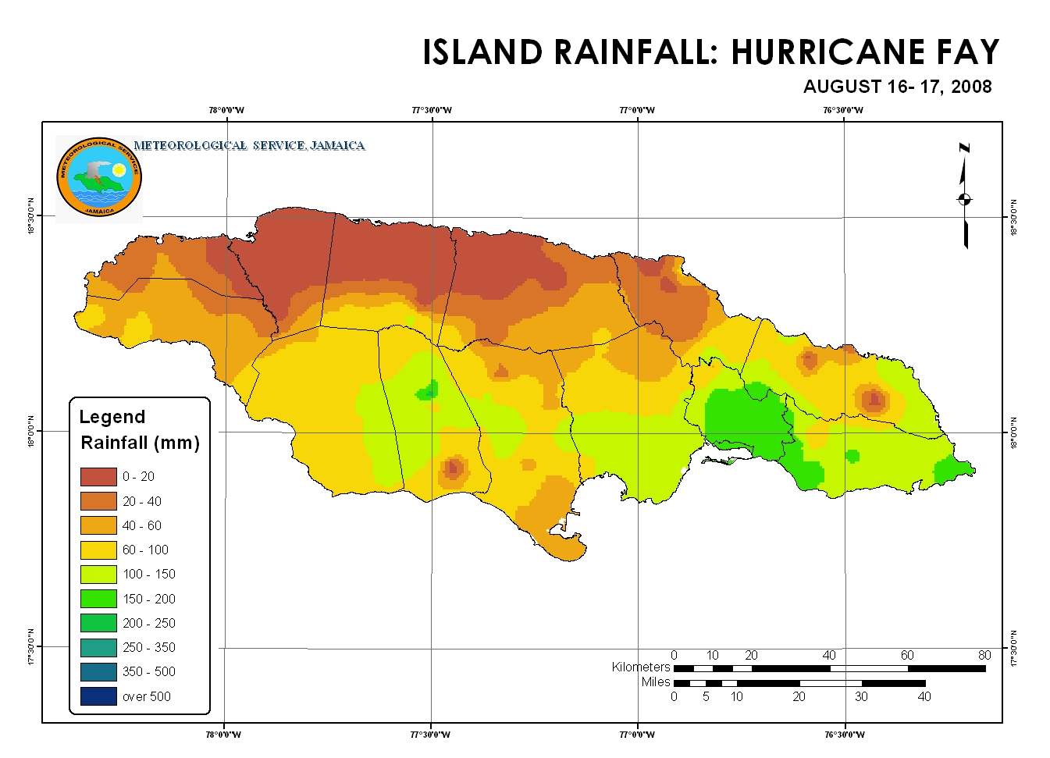
FAY: - August 16-17
Jamaican have a feint recollection of the threat posed by Tropical storm Fay coming at the same time that all eyes were focussed on the track at the Beijing Olympics. Fay developed near the eastern coast of the Dominican Republic on August15 and was projected to pass just north of Jamaica by August 17.

Bulletin #1 was issued by the Meteorological Service at 8:00 a.m. on August 16 and the second bulletin at 11:00 a.m. included a tropical storm watch for the island. Fay’s passage off Jamaica’s coast was expected to begin late that night and was heralded by the first signs of rainfall near 8:00 p.m. The watch was discontinued at 2:00 p.m. on August 17, some time after Fay made its closest pass near 135 kilometres from the coastline. Over the period 10 bulletins were issued.
Figure 1

GUATAV: - August 25-29
Tropical Storm Gustav developed from the season’s 7th tropical depression south of Hispaniola on August 25. This was communicated to the Jamaican public by 5:00 p.m. and its threat was emphasized in a tropical storm watch at 10:00 p.m. Gustav was forecast to pass between Jamaica and Cuba on August 27 and seemed to follow the script for the next 24 hours. Offshore fishermen were issued evacuation orders on morning of August 26 and the system weakened considerably while passing over southern Haiti. Gustav continued to threatened northern and eastern parishes of Jamaica with rainfall which was expected to start the following day.

A tropical storm warning was put into effect during the morning of August 27 and by the end of the day Gustav was project to move north of the island during the night. The nation woke up the following morning with the news that Gustav had been relocated just east of Jamaica and would begin moving along the southern coastline later that day. A hurricane warning was issued at 6:00 a.m. as Gustav strengthened to near-hurricane strength and approached Kingston. For 18 hours, between 28/1400 LST and 29/0800 LST, the centre of Gustav was detected by Doppler radar moving slowly from the easternmost to westernmost points of the island.
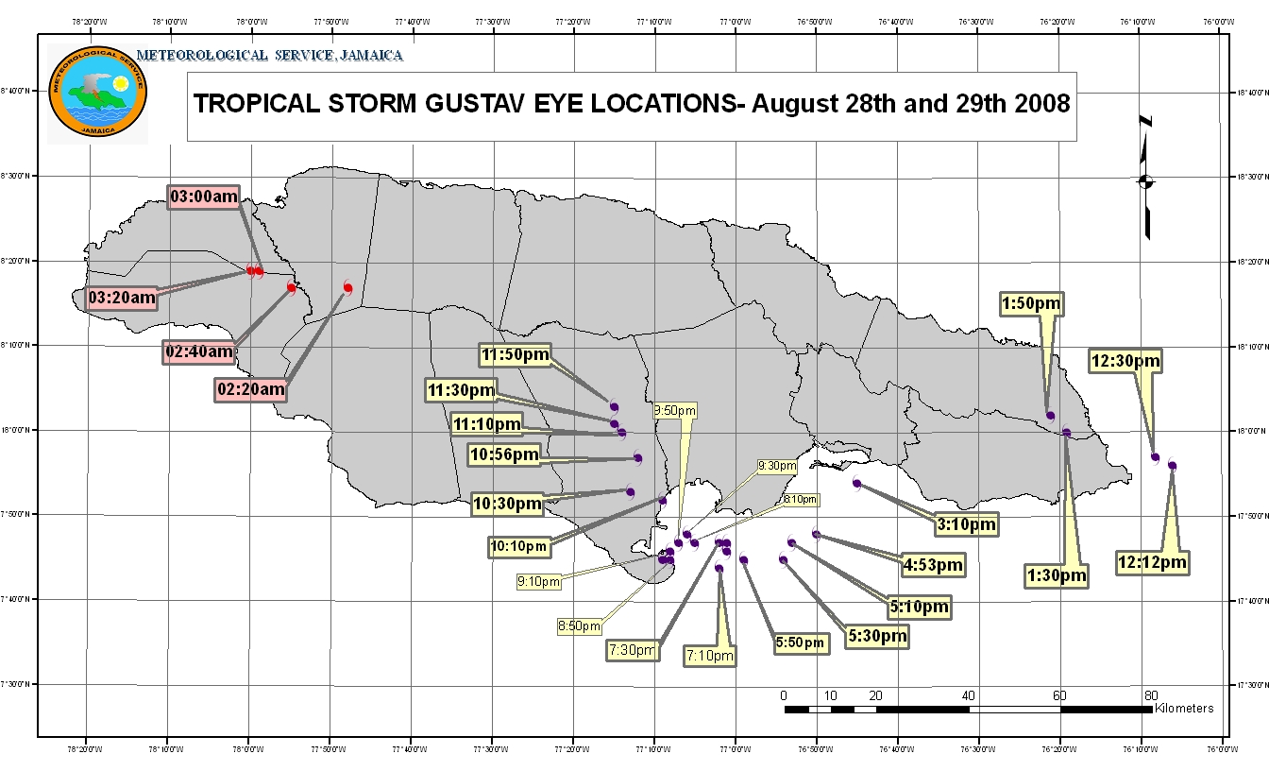

Figure 2

The hurricane warning was downgrade to a tropical storm warning at 11:00 a.m. on August 29, with Gustav about 50 kilometres to the west of the island and moving away. The tropical storm warning was lifted the next morning at 5:00 a.m. Over the period 30 bulletins were issued.
The Mavis Bank station in rural St. Andre recorded 419 mm of rainfall (388% of the climatological monthly mean) on august 28 and a 3-day total of 534.6 mm on August 27-29. The rain rate at the station peaked at 80 mm/h.

The lowest barometric pressure of 988.7 mb was recorded by an amateur radio operator at 3:19 p.m. on august 28 during the event. Comparative readings of 992.0 mb were recorded in Montego Bay and 990.4 mb in Kingston as the storm’s centre moved from east to west.

The maximum sustained wind recorded during Gustav’s passage was 86 kmh⁻¹, which was measured at Stony Hill, St Andrew at 2:41 p.m. on August 28. Kingston recorded sustained winds of 85 kmh⁻¹ at 6:17 that evening and a gust of 117kmh⁻¹ at 5:37 p.m.

Gustav caused 15 deaths across Jamaica and approximately US $210 million in damage.

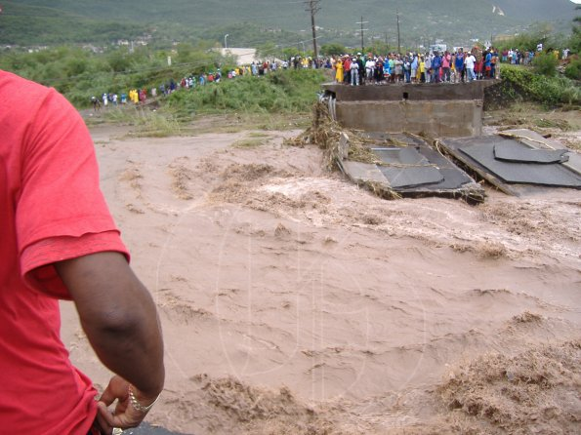
Figure 3: Damage to Bridge Network

IKE: - September 7-8
Over the period September 1-6, tropical depression #9 developed over the tropical Atlantic Ocean and strengthened to become category 4 hurricane Ike just north of the Greater Antilles. Jamaica issued a tropical storm watch during the afternoon of September 7. Rainfall associated with the system began affecting Jamaica that night, even as Ike was weakening and moving inland over Central Cuba. The tropical storm watch was lifted at 2:00 p.m. on September 8. Over the period 7 bulletins were issued.

PALOMA: - November 4-9
Tropical depression #17 developed on November 5 out of a broad area of low pressure over the south-western Caribbean Sea. This started out as a frontal system that moved into the north-western section of the Basin inducing a low-level trough southward. Period of showers and thunderstorms persisted in the vicinity of Jamaica for days initiating flash flood watches and warnings.

On November 6, the Depression was upgraded to Tropical Storm Paloma and was projected to quickly strengthen and move near northward some distance west of Jamaica. The system became a hurricane later that evening. By the following morning, Paloma was passing over 300 kilometres west of the island and further strengthening to category 4 status occurred on November 8 with its centre about 230 kilometres from the island’s westernmost point. Flash flood warning remained in effect until the system was over central Cuba during the evening of November 9. There was one death due to the rainfall caused by Paloma.

CONCLUSION
There is a general tendency among Jamaicans to underestimate the potential threat of tropical storms, as compared to hurricanes as they move towards the island. Season ’08 has, however, brought a stark reminder of the damage that can be sustained by a tropical cyclone that was determined to be too weak for classification as a category 1 hurricane. The accumulated rainfall from the Gustav event was comparable to Ivan of 2004 (which was a category 4 hurricane) in some sections of the island and resulted in significant floods and landslides.

